**SECTION 1: GETTING STARTED**

**1. Welcome to the Course! (1.39m)**

**2. What is "Vue.js"? (7:51m)**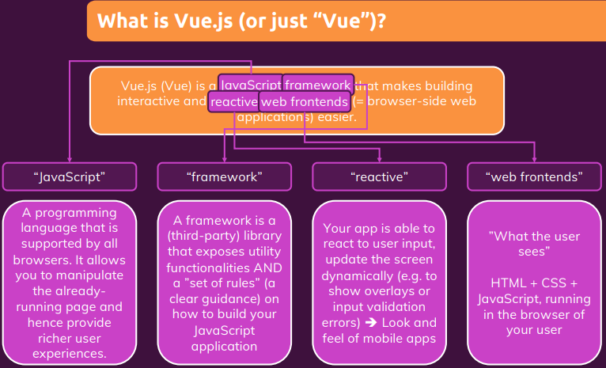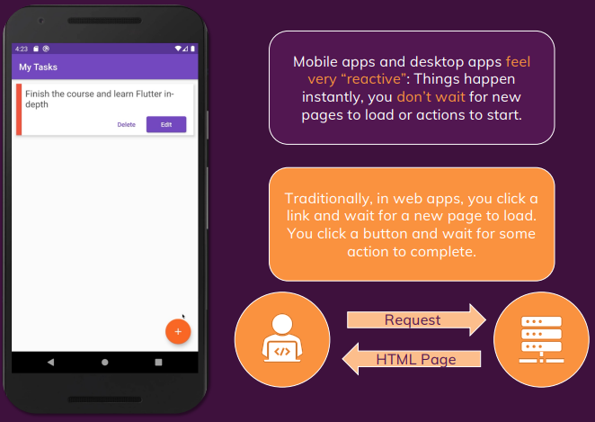  
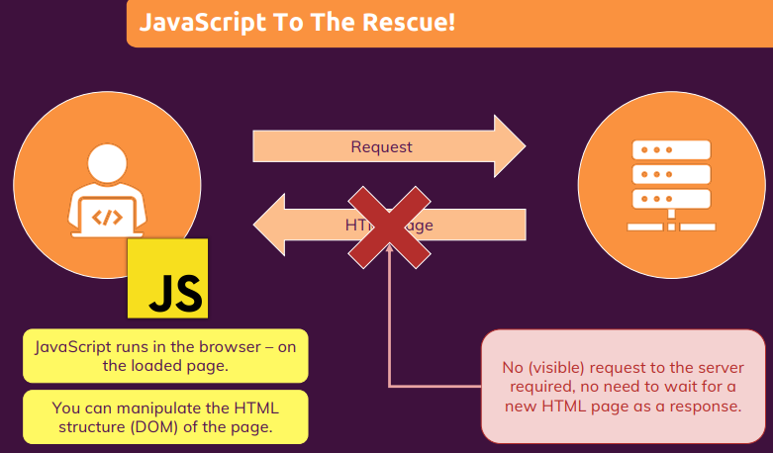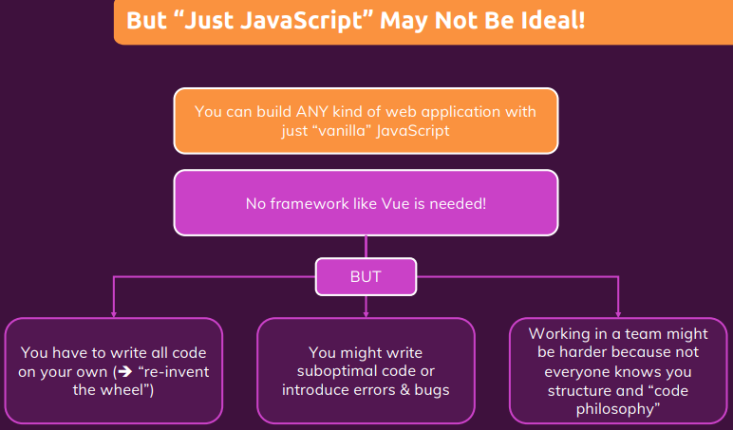

**3. Different Ways of Using Vue (2:35m)**

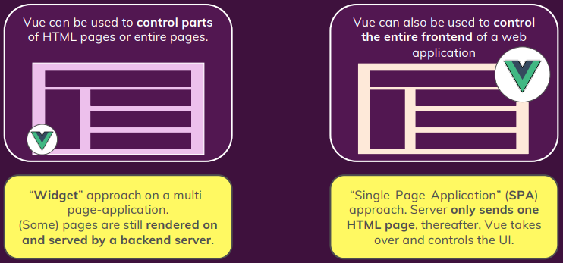

**4. Exploring Vue Alternatives + Resources (3:11m)**

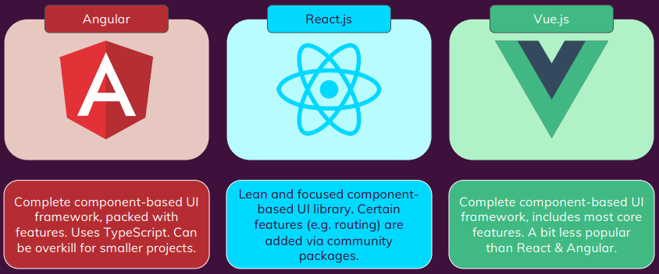

[Angular vs React vs Vue - My Thoughts (academind.com)](https://academind.com/tutorials/angular-vs-react-vs-vue-my-thoughts)

**5. Building A First App With Just JavaScript + Resources (7:26m)**

Resource: gs-02-first-app-with-just-js

**6. Join our Online Learning Community**

[Find up-to-date tutorials. (academind.com)](https://academind.com/tutorials/)

**7. Re-building the App with Vue + Resources (11.39m)**

[Quick Start | Vue.js (vuejs.org)](https://vuejs.org/guide/quick-start.html)  
Note: In index.html, vue from CDN script tag must be above app.js script tag.

Resource: gs-03-rebuilding-the-app-with-vue

**8. Vue vs "Vanilla JavaScript" (just JavaScript) (1:10m)**

With vue, it’s simpler to write code for larger applications.

**9. Setting Up the Course Development Environment (2:04m)**

IDE: Visual Studio Code

Extention: Prettier - Code formatter, use to format editor code.

**10. Course Outline & What's In The Course (2:57m)**

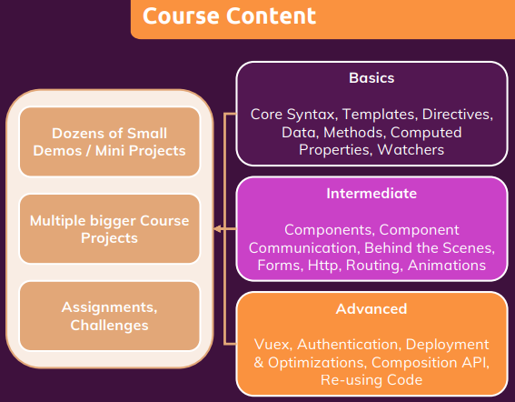

**11. How To Get The Most Out Of This Course (3:23m)**

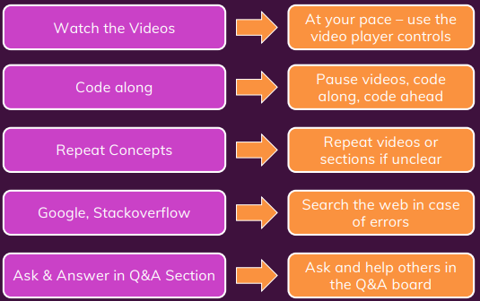

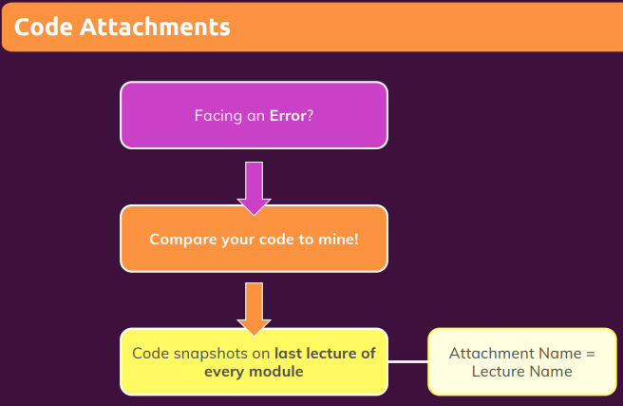

**12. Module Resources + Resources**